- Volume of solids
1. Metal cube of side 4.4cm was melted and the molten material used to make a sphere. Find to 3 significant figures the radius of the sphere 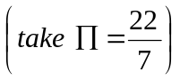 (3 mks)
2. Two metal spheres of diameter 2.3cm and 3.86cm are melted. The molten material is used to cast equal cylindrical slabs of radius 8mm and length 70mm.
If ¹/₂₀ of the metal is lost during casting. Calculate the number of complete slabs casted. (4mks)
3. The volume of a rectangular tank is 256cm³. The dimensions are as in the figure.

¼ x

x-8
16cm

Find the value of x (3 marks)

4.
R=14cm

22.5cm

21cm

The diagram represent a solid frustum with base radius 21cm and top radius 14cm. The frustum is 22.5cm high and is made of a metal whose density is 3g/cm3 π = 22/7.
- Calculate
  - the volume of the metal in the frustrum. (5 marks)
  - the mass of the frustrum in kg. (2 marks)
- The frustrum is melted down and recast into a solid cube. In the process 20% of the metal is lost. Calculate to 2 decimal places the length of each side of the cube. (3 marks)
5. The figure below shows a frustrum
2.2 cm
3.3 cm
4.8 cm

Find the volume of the frustrum (4 mks)
6. The formula for finding the volume of a sphere is given by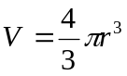. Given that V = 311 and =3.142, find r. `(3 mks)
7. A right conical frustrum of base radius 7cm and top radius 3.5cm, and height of 6cm is stuck onto a cylinder of base radius 7cm and height 5cm which is further attached to a hemisphere to form a closed solid as shown below
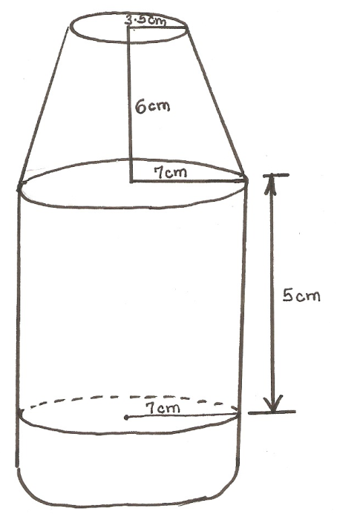
Find:
(a) The volume of the solid (5mks)
(b) The surface area of the solid (5mks)
8. A lampshade is made by cutting off the top part of a square-based pyramid VABCD as shown in the figure below. The base and the top of the lampshade have sides of length 1.8m and 1.2m respectively. The height of the lampshade is 2m
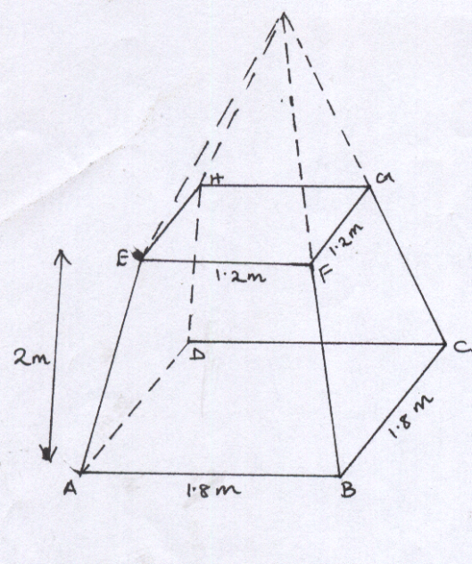
Calculate
- The volume of the lampshade (4mks)
- The total surface area of the slant surfaces (4mks)
- The angle at which the face BCGF makes with the base ABCD. (2mks)
9. A solid right pyramid has a rectangular base 10cm by 8cm and slanting edge 16cm.
calculate:
(a) The vertical height
(b) The total surface area
(c) The volume of the pyramid

10. A solid cylinder of radius 6cm and height 12cm is melted and cast into spherical balls
of radius 3cm. Find the number of balls made

11. The sides of a rectangular water tank are in the ratio 1: 2:3. If the volume of the tank is
1024cm³. Find the dimensions of the tank. (4s.f)

12. The figure below represents sector OAC and OBD with radius OA and OB respectively.
Given that OB is twice OA and angle AOC = 60º. Calculate the area of the shaded region
in m², given that OA = 12cm
B
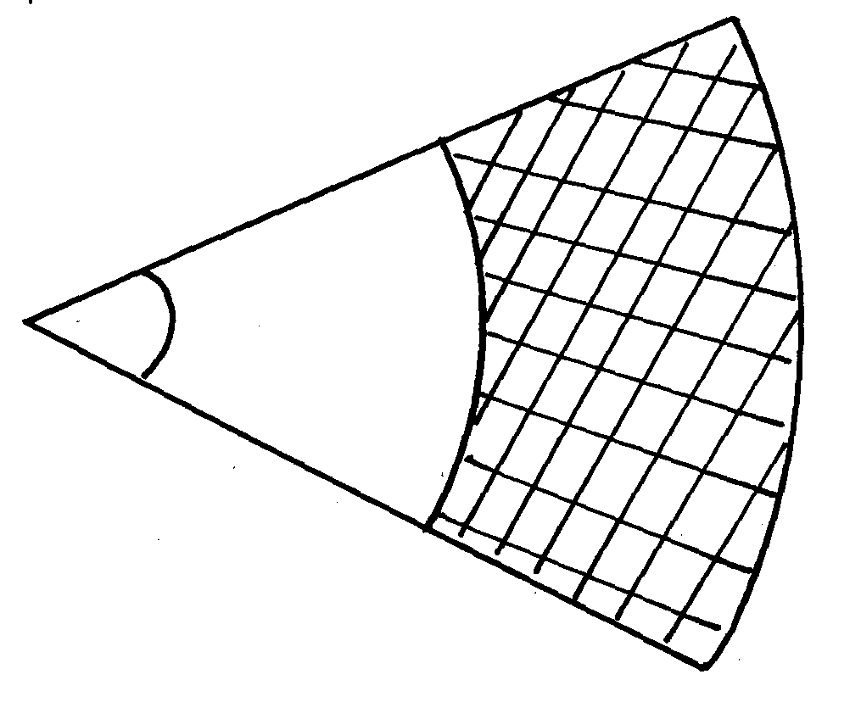
A

60º
O

C

D

13. The figure below shows a closed water tank comprising of a hemispherical part surmounted
on top of a cylindrical part. The two parts have the same diameter of 2.8cm and the cylindrical
part is 1.4m high as shown:-
1.4m
d =2.8m

- Taking π= 22, calculate:
7
(i) The total surface area of the tank
(ii) the cost of painting the tank at shs.75 per square metre
(iii) The capacity of the tank in litres
(b) Starting with the full tank, a family uses water from this tank at the rate of 185litres/day
for the first 2days. After that the family uses water at the rate of 200 liters per day. Assuming
that no more water is added, determine how many days it takes the family to use all the water
from the tank since the first day
14. The figure below represents a frustrum of a right pyramid on a square base. The vertical height
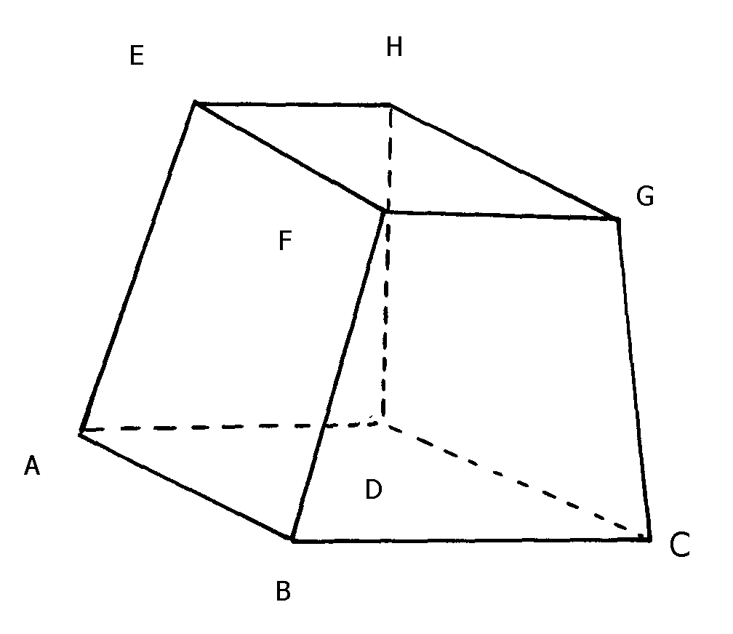
of the frustrum is 3 cm. Given that EF = FG = 6 cm and that AB = BC = 9 cm

Calculate;
a) The vertical height of the pyramid.
b) The surface area of the frustrum.
c) Volume of the frustrum.
d) The angle which line AE makes with the base ABCD.
15. A metal hemisphere of radius 12cm is melted done and recast into the shape of a cone
of base radius 6cm. Find the perpendicular height of the cone

16. A solid consists of three discs each of 1½ cm thick with diameter of 4 cm, 6 cm and 8 cm
respectively. A central hole 2 cm in diameter is drilled out as shown below. If the density of
material used is 2.8 g/cm³, calculate its mass to 1 decimal place

17. A right conical frustrum of base radius 7 cm and top radius 3.5 cm and height 6 cm is stuck onto a
cylinder of base radius 7 cm and height 5 cm which is further attached to form a closed solid as
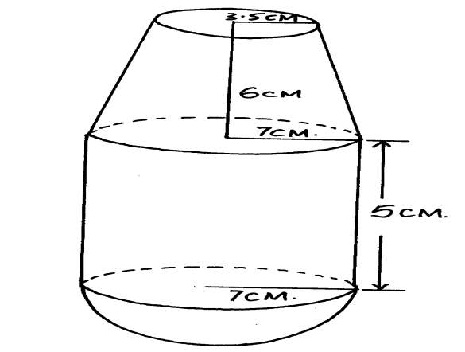
shown below.

Find;

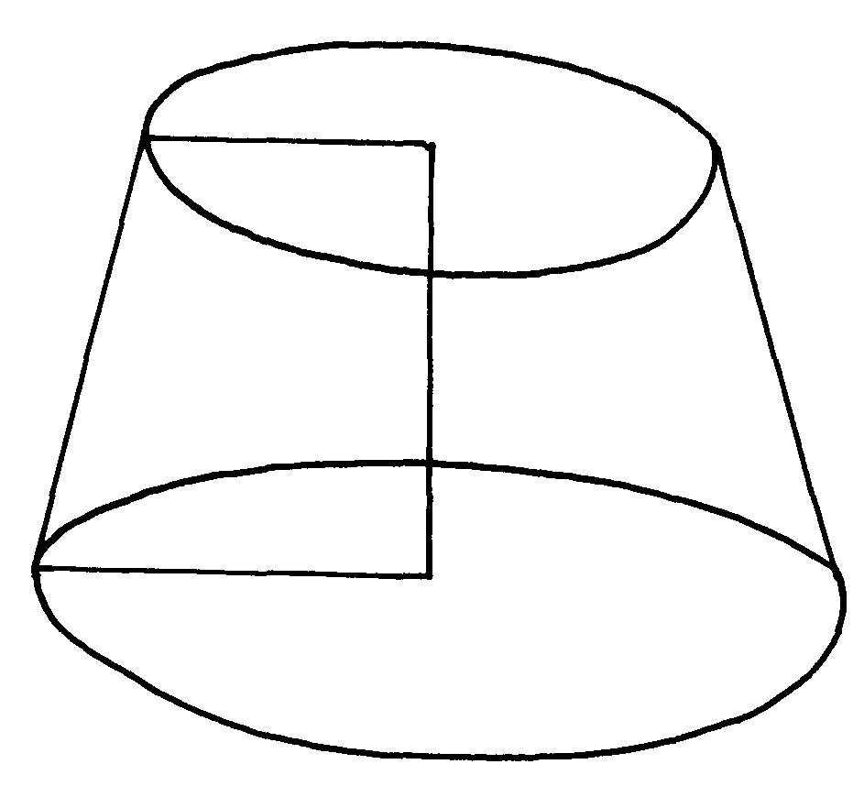
18. The figure below shows a frustrum
2.2cm

4.8cm

3.3cm

Find the volume of the frustrum
19. The diagram below shows a metal solid consisting of a cone mounted on hemisphere.
r
The height of the cone is 1½ times its radius;

Given that the volume of the solid is 31.5π cm³, find:
(a) The radius of the cone
(b) The surface area of the solid
(c) How much water will rise if the solid is immersed totally in a cylindrical container which
contains some water, given the radius of the cylinder is 4cm
(d) The density, in kg/m³ of the solid given that the mass of the solid is 144gm

20. A solid metal sphere of volume 1280 cm³ is melted down and recast into 20 equal solid cubes.
Find the length of the side of each cube.

21. The figure below shows a frustrum cut from a cone
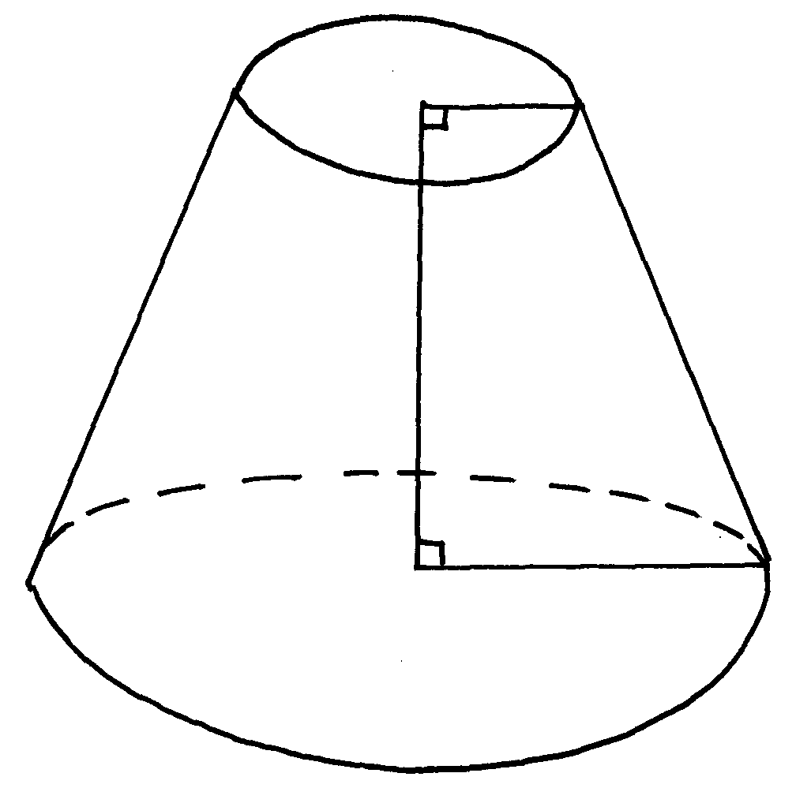
9cm
3cm
14cm

Calculate the volume of the frustrum

